**Connecting to The Epson Projector Wirelessly**

From a PC-

Make sure the Laptop or 2 in 1 is connecting to Mobil_Devices at the High School ( for the Middle Schools and Elementary schools you will be connected to WTPS_Wireless)

Turn the projector on, using the remote, click on the LAN source button on the upper right hand side.

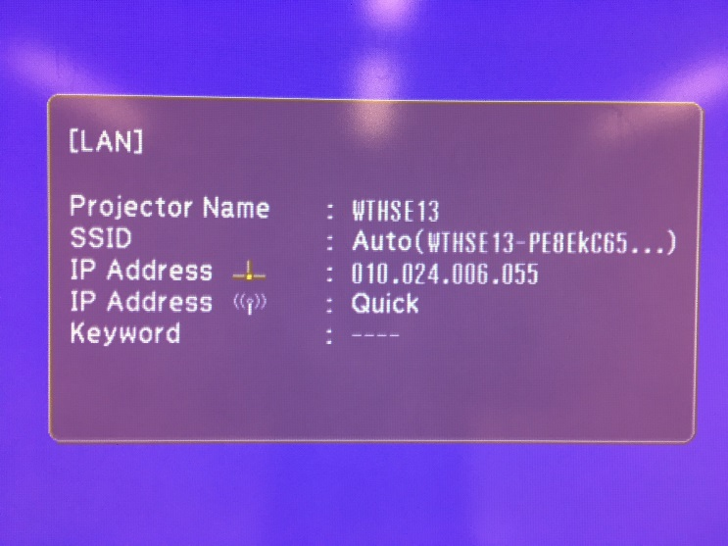

An IP address will appear in the dialog box, projected on your whiteboard.

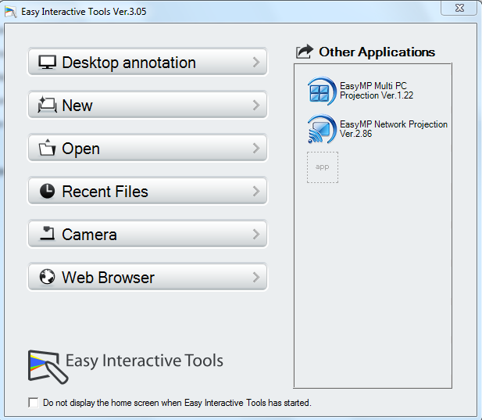

On your device, Open the Easy Interactive Tools and click on Easy MP Network Projection

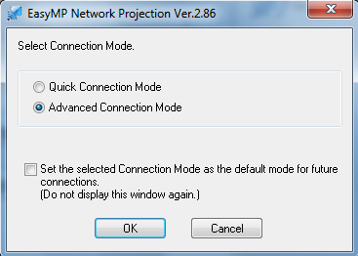

Click on Advanced Mode, then OK

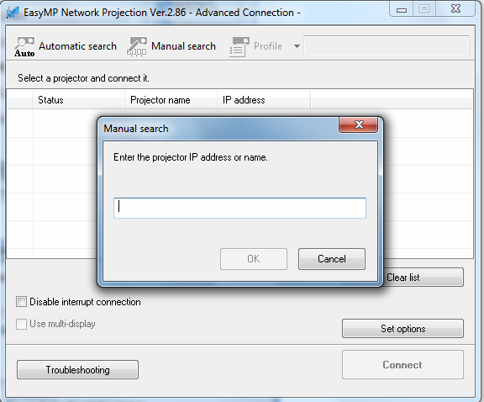

Insert the IP address as seen on your projected image and click ok

Select Manual Search.

You will get a Dialog box prompting you for an IP address.

Put the IP address from your projector in the space provided.

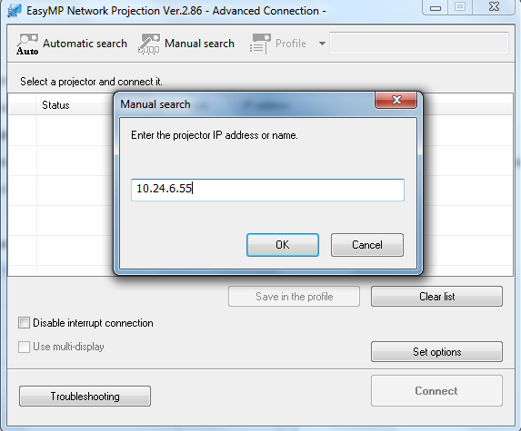

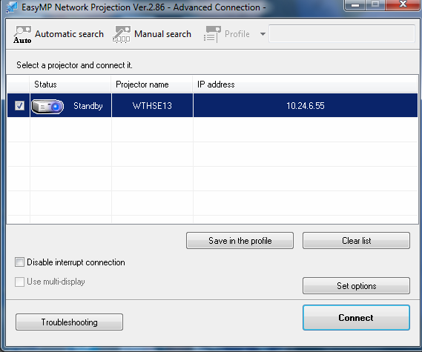

Your projector will show up in the Advanced Connection Box. Click on connect.

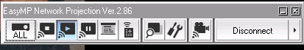

Disconnect when you are finished.